All the Digits

Stage: 2

This represents the multiplication of a 4-figure number by 3.
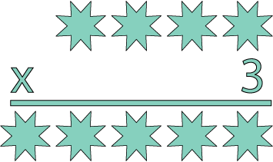
The whole calculation uses each of the digits 0−9 once and once only.
The 4-figure number contains three consecutive numbers, which are not in order. The third digit is the sum of two of the consecutive numbers.
The first, third and fifth figures of the five-digit product are three consecutive numbers, again not in order. The second and fourth digits are also consecutive numbers.
Can you replace the stars in the calculation with figures?

